TripConnect



A project report
Submitted in partial fulfillment of the Degree of
Bachelor of Technology
in
Computer Science Engineering
by
Sakshi Agarwal (2316526)
Nandini Gupta (2316476)
Smriti Sharma (2316567)
Nishtha Garg (2316489)

Under the supervision of
Dr. Vaibhav Vyas
Associate Professor

DEPARTMENT OF COMPUTER SCIENCE
BANASTHALI VIDYAPITH, RAJASTHAN
Session- 2025-26

CERTIFICATE

This is to certify that the project work titled “TripConnect” submitted by “Sakshi Agarwal (2316526) Nandini Gupta (2316476) Smriti Sharma (2316567) Nishtha Garg (2316489)” in partial fulfilment for the award of degree B.Tech in CSE of Banasthali Vidyapith has been carried out under my supervision. This work has not been submitted partially or wholly to any other university or institute for the award of this or any other degree.

Dr. Vaibhav Vyas
Associate Professor
Banasthali Vidyapith,Rajasthan-304022
Date-April 02 ,2026

ABSTRACT

Traveling has become an important part of modern life, offering opportunities for exploration, relaxation, and personal growth. However, planning a trip is not always easy. Many individuals face difficulties in finding compatible travel companions, organizing itineraries, and choosing suitable travel plans that match their interests. This often leads to confusion, wasted time, and less satisfying travel experiences.
To overcome these challenges, we developed TripConnect, a travel-based website designed to simplify and enhance the overall travel planning process. The platform helps users find ideal travel companions by matching them based on shared interests, preferences, and travel goals. This feature not only makes it easier to connect with like-minded people but also improves the overall quality of the travel experience.
In addition to this, TripConnect offers a Self Group feature that provides users with access to inbuilt travel packages. These packages allow users to quickly explore and select trips without going through the hassle of planning everything from scratch. Furthermore, the platform includes a custom trip planning feature, enabling users to design their own journeys with well-structured and organized itineraries tailored to their needs.
By combining social connectivity with smart planning tools, TripConnect creates a seamless, user-friendly, and personalized travel experience. It reduces the stress of trip planning while encouraging meaningful connections among travelers, making journeys more enjoyable, efficient, and memorable.

ACKNOWLEDGEMENT

We would like to extend our deepest appreciation and heartfelt gratitude to Dr. Vaibhav Vyas Sir for his invaluable support and mentorship throughout the completion of our internship project. His consistent guidance, exemplary patience, and insightful feedback were instrumental in shaping the direction and success of our work. We are truly thankful for his encouragement and for fostering an environment that allowed us to grow both technically and professionally.
We also acknowledge the contributions of many other individuals who played an important role in the development of this project. We are especially grateful to the coordinators and faculty members of our department for their valuable comments, constructive suggestions, and continuous motivation, which enriched our learning experience and helped refine the project further.
A special thanks goes to our families and friends whose support, advice, and encouragement inspired us to keep striving for excellence. Their belief in us, along with their shared knowledge and time, significantly contributed to our project’s progress and success.
We are sincerely thankful to our affiliated college, Banasthali Vidyapith, for granting us the opportunity to critically analyze a real-world problem—the commuting difficulties faced by students—and allowing us to work on a practical and impactful solution. This project not only deepened our technical understanding but also enhanced our problem-solving, collaboration, and user-centered design skills.
As dedicated and enthusiastic students, we take great pride in representing Banasthali Vidyapith with professionalism and commitment. The experience gained through this project has been truly transformative and will undoubtedly serve as a strong foundation for our future endeavors in the field of engineering.

TABLE OF CONTENTS

- Introduction to TripConnect

- Requirement Analysis (SRS)
- Requirement Specification
- Hardware and Software Requirements
- Feasibility Study
- Product Functions
- Use-Case Diagrams

- System Design (SDS)
- Class Diagram
- Database Design
- Data Flow Diagrams
- Activity Diagrams
- Sequence Diagrams

- Coding
- Testing
- User Interfaces
- Appendices
- References

INTRODUCTION TO TRIPCONNECT
TripConnect is a comprehensive web-based travel platform designed to simplify and enhance the travel planning experience. The system allows users to create customized trips by selecting destinations, travel dates, budgets, and personal preferences, offering flexibility to travellers who wish to design their own journeys. At the same time, the platform provides a wide range of inbuilt travel packages curated to suit different travel types such as solo, family, or group trips, ensuring convenience for users who prefer ready-made options.
The website also integrates matchmaking features, enabling travellers to connect with like-minded companions, along with secure payment processing for bookings and refunds. Additional functionalities such as messaging, notifications, reviews, and travel history make TripConnect an all-in-one travel companion. By combining customization and pre-designed packages, TripConnect bridges the gap between independent travel planning and professional tour services, providing a seamless, user-friendly, and efficient solution for modern travellers.

REQUIREMENT ANALYSIS OF TRIPCONNECT
- Requirement specification

User Interface
This software product, TripConnect, is a travel-based web platform designed for users who wish to plan trips and find compatible travel companions. The platform will be accessible through web browsers on desktops, laptops, and mobile devices, ensuring ease of use and accessibility for all users.

The system consists of multiple pages based on different functionalities. For example, there will be separate pages for login, sign-up, dashboard, travel buddy search, trip planning, and package exploration.

To access the system, each user must create an account using a unique username and password. During the sign-up process, users will be required to verify their email to ensure authenticity and security. Once registered, user information will be securely stored and managed in a database.

After logging in, users can explore features such as finding travel companions based on shared interests, joining or creating self-groups, selecting inbuilt travel packages, and designing customized trips with detailed itineraries. Users can also log out of the system at any time.

Assumptions

- User Participation: It is assumed that a sufficient number of users will actively use the platform to find travel companions.
- Interest Matching: Users will provide accurate preferences and interests to enable effective matching with suitable travel buddies.
- Travel Intent: Users are genuinely interested in traveling and open to connecting with new people.
- User Reliability: Users are expected to communicate responsibly, follow plans, and maintain respectful behavior during interactions.
- Internet Accessibility: Users have access to stable internet connections to use the web platform smoothly.

Dependencies

- Internet Connectivity: The platform depends on reliable internet access for smooth functioning and real-time interactions.
- Database Management System: Efficient storage and retrieval of user data, preferences, and trip details depend on a robust database system.
- User Engagement: The effectiveness of the platform depends on active participation and consistent usage by users.
- Security and Authentication: Proper authentication systems (like email verification) are required to ensure data security and user trust.

- Hardware and Software Requirements

Hardware Interfaces

Server Side:
Processor: Intel i3 or higher / equivalent
Primary Memory (RAM): 8 GB
Secondary Storage: 50 GB hard disk
Network: Stable internet connection for hosting and database access

Client Side:
Processor: Dual-core processor
Primary Memory (RAM): 4 GB
Secondary Storage: 16 GB free space
Device: Laptop, desktop, or smartphone
Network: Internet connection required

Software Interfaces

Server Side:
Backend Technology: Node.js / Express.js
Database: MySQL
Operating System: Windows / Linux / macOS
Web Server: Node server
Client Side:
Operating System: Windows, Linux, macOS, Android, or iOS
Browser: Google Chrome, Mozilla Firefox, Microsoft Edge, Safari, etc.
Frontend Technology: HTML, CSS, JavaScript

- Feasibility Study

Intended Audience
The website TripConnect is designed for individuals who are interested in traveling and exploring new places while connecting with like-minded people. The platform primarily targets students and young travelers, but it can be used by anyone looking for travel companions or planning trips.
The main goal of this system is to simplify the process of finding suitable travel buddies and organizing trips efficiently. This document outlines the features of the system and defines how users interact with the platform. It also provides a clear understanding of how TripConnect helps users plan, customize, and manage their travel experiences in a more social and convenient way.

Product Scope
TripConnect is a web-based platform designed to enhance the travel planning experience by combining social interaction with smart trip organization. The system allows users to create and manage their profiles securely using unique login credentials.
The platform enables users to find travel companions based on shared interests, preferences, and travel goals. Users can either join existing groups or create their own travel groups using the Self Group feature, which includes pre-designed travel packages for easy selection.
Additionally, TripConnect provides a custom trip planning feature, allowing users to design personalized trips with properly structured itineraries. This helps users plan their journeys efficiently without relying on external tools.
Overall, the system acts as a centralized platform where users can connect, plan, and organize their trips in a seamless and user-friendly environment.

Product Perspective
TripConnect is an independent and self-contained web application. It is designed to function efficiently without heavy dependence on external systems. The platform includes all essential components such as user registration, interest-based matching, trip planning, and itinerary management within its own framework.
Its modular design allows it to be scalable and adaptable for future enhancements, such as integrating additional services like maps, payment gateways, or communication features. This flexibility ensures that the system can evolve according to user needs while maintaining performance and usability.
The platform’s self-sufficiency makes it easy to deploy, maintain, and expand, providing a reliable and efficient solution for modern travel planning.

- Product Functions

This section outlines the key functionalities provided by TripConnect. These functions define how users interact with the system and utilize its features to plan trips and connect with suitable travel companions.

Core Functions
- Sign Up: Users can register on the platform by providing necessary details such as name, email, and password. This allows them to access the system.
- Login: Registered users can log in using their credentials to access their account and use the platform features.
- Logout: Users can log out of the system securely through their profile section.
- Enter Preferences: Users can enter their travel preferences such as destination, interests, budget, and travel dates. These preferences are used to match users with suitable travel groups.
- Travel Buddy Matching: Based on the entered preferences, the system matches users with like-minded individuals to form travel groups.
- Inbuilt Packages: The platform provides pre-designed travel packages that users can explore and choose from for convenience.
- Self Group: Users can create their own travel groups with people they already know.
- Find Travel Group: Users can browse and explore available travel groups based on their preferences.
- Join Group: Users can join a travel group if they find it suitable for their travel plans.
- Profile Management: Users can view and update their personal details, preferences, and activity within the platform.

Services Permitted by the System:

- User Access: Registered users can log in and access all features of the system.
- Search and Join Trips/Groups: Users can search for travel groups and join them based on their preferences.
- Travel Buddy Matching: The system provides matching functionality to connect users with compatible travel companions.
- Group and Package Management: Users can join, and manage groups, as well as explore inbuilt travel packages.
- User Control: Users have control over their profile, preferences, and group participation.
- Admin Control: Admin can manage users, monitor activities, and maintain the overall functioning and security of the system.
- User Logout: Users can securely log out of the platform at any time.

- Use-Case Diagrams

- Guest Visitor

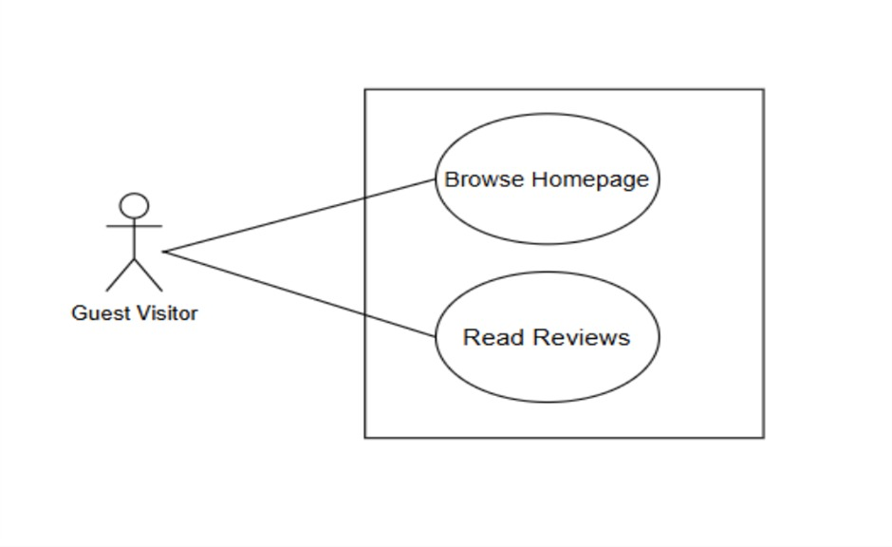
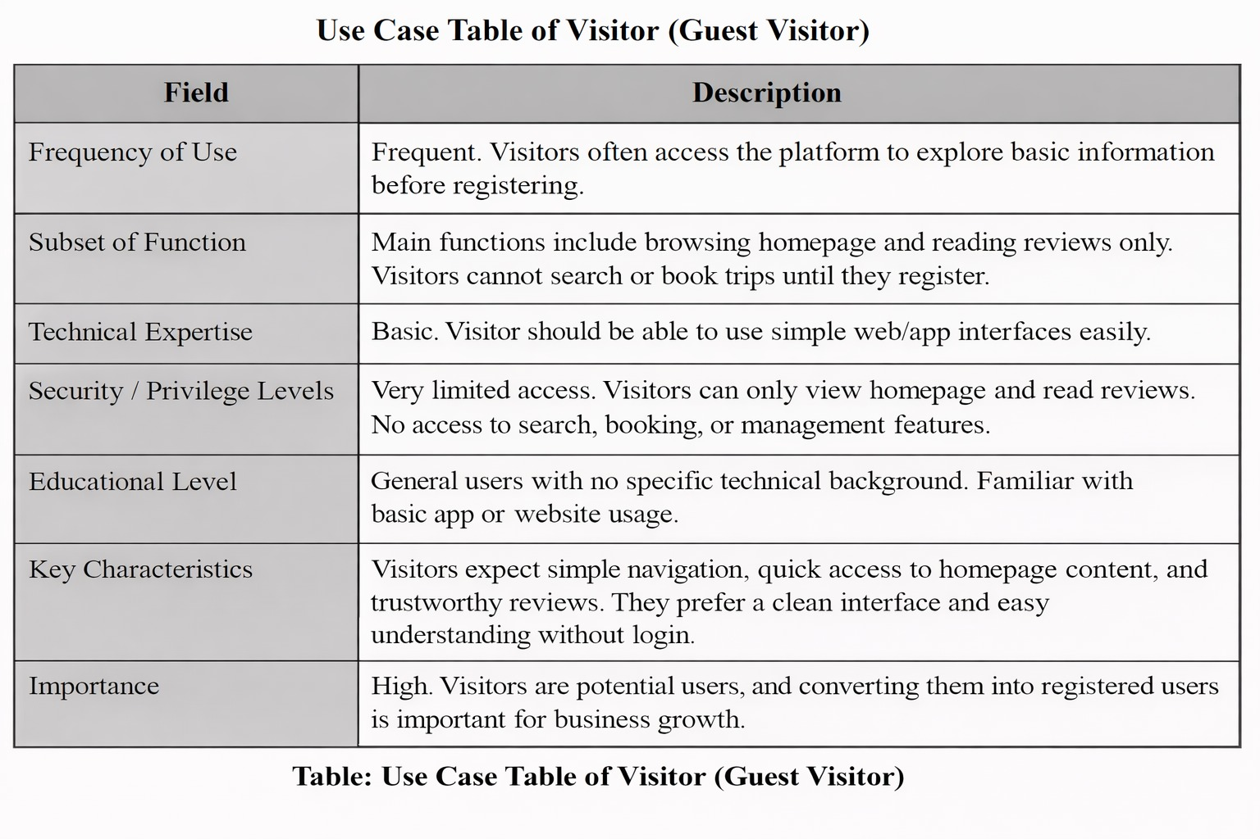

- User

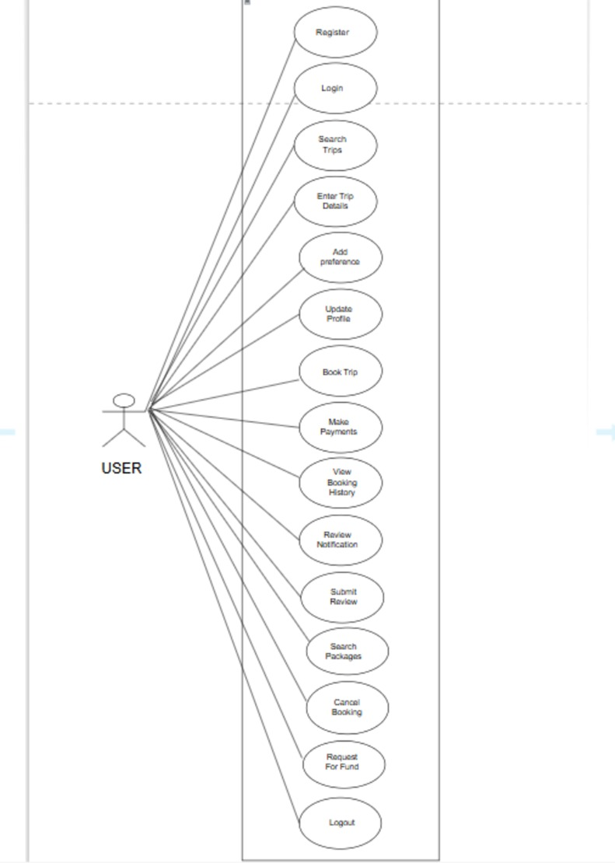

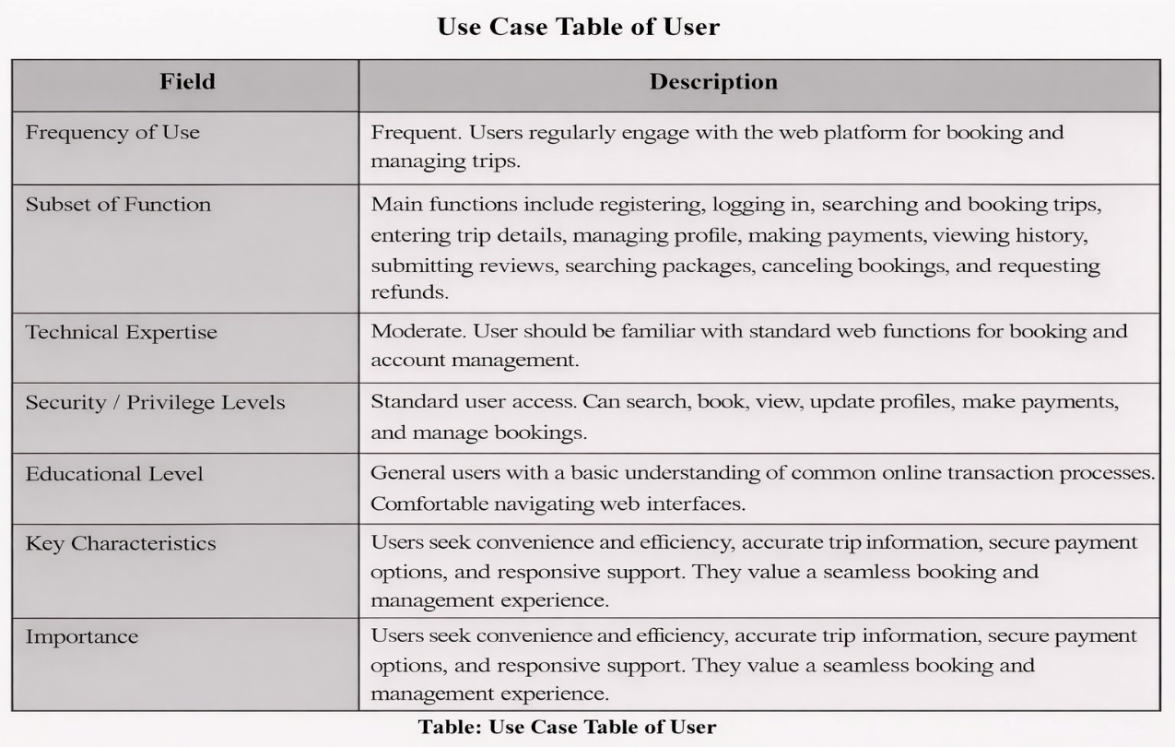

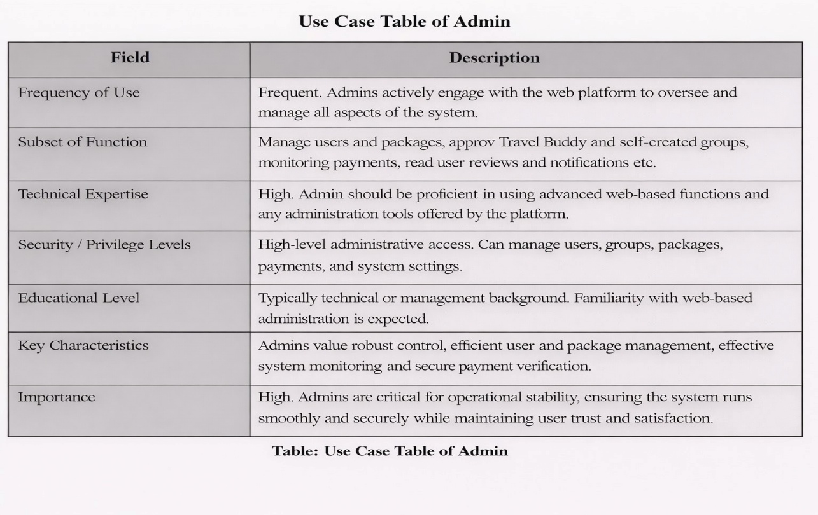

- Admin

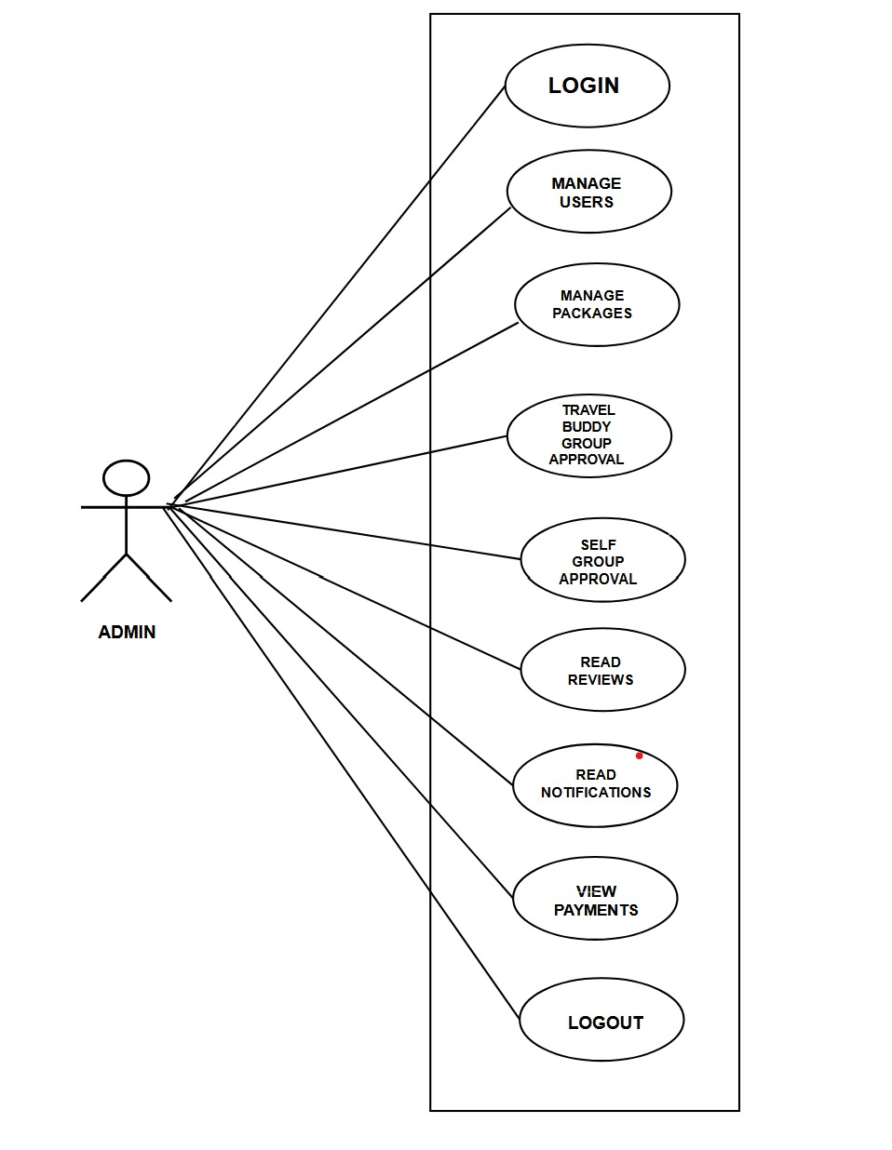

System Design Specification

- Class Diagram

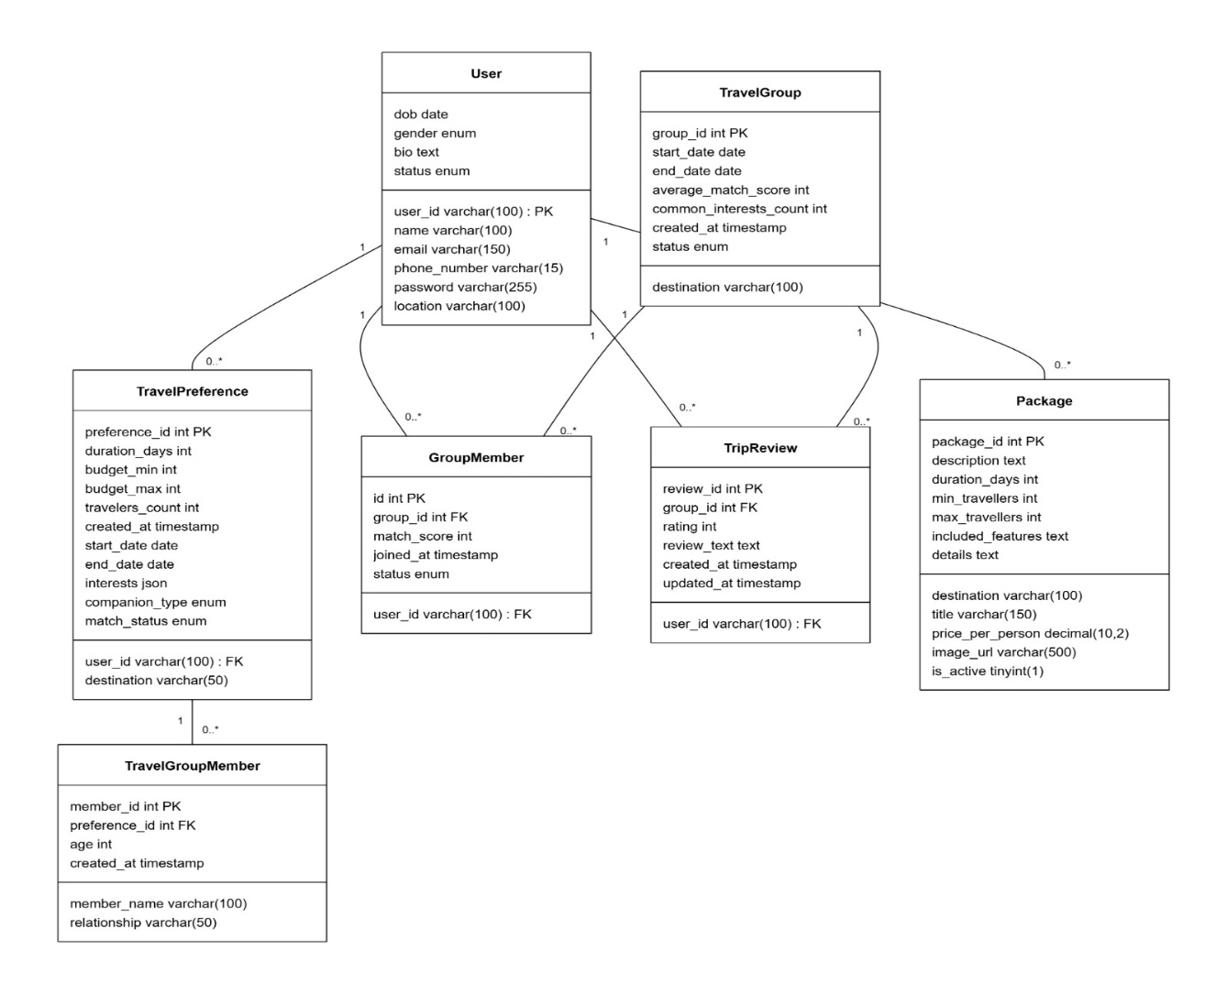

- Database Design

Users

Column | Type | Constraints
user_id | VARCHAR(100) | Primary key
name | VARCHAR(100) | NOT NULL
email | VARCHAR(150) | NOT NULL, UNIQUE
phone_number | VARCHAR(15)
password | VARCHAR(225) | NOT NULL
dob | Date
gender | ENUM('Male', 'Female', 'Prefer not to say')
bio | TEXT
location | VARCHAR(100)
status | ENUM('active', 'suspended', 'pending') | DEFAULT 'pending'

Travel Preferences

Field | Type | Description
preference_id | INT | AUTO_INCREMENT, PRIMARY KEY
user_id | VARCHAR(100) | NOT NULL, FOREIGN KEY → users(user_id)
budget_min | INT
budget_max | INT
travelers_count | INT
created_at | TIMESTAMP | DEFAULT CURRENT_TIMESTAMP
destination | VARCHAR(50)
start_date | DATE
end_date | DATE
duration_days | INT
interests | JSON
companion_type | ENUM('self-group', 'buddy')
match_status | ENUM('pending', 'searching', 'matched', 'completed', 'cancelled') | DEFAULT 'pending'

Packages
Field | Type | Description
package_id | INT | AUTO_INCREMENT, PRIMARY KEY
destination | VARCHAR(100) | NOT NULL
title | VARCHAR(150) | NOT NULL
description | TEXT
price_per_person | DECIMAL(10,2) | NOT NULL
duration_days | INT | NOT NULL
min_travellers | INT | NOT NULL
max_travellers | INT | NOT NULL
included_features | TEXT
image_url | VARCHAR(500)
is_active | TINYINT(1) | DEFAULT 1
details | TEXT

Travel Groups
Column | Type | Constraints
group_id | INT | AUTO_INCREMENT, PRIMARY KEY
destination | VARCHAR(100) | NOT NULL
start_date | DATE | NOT NULL
end_date | DATE | NOT NULL
average_match_score | INT
common_interests_count | INT
created_at | TIMESTAMP | DEFAULT CURRENT_TIMESTAMP
status | ENUM('forming', 'active', 'completed', 'cancelled') | DEFAULT 'forming'

Travel Group Members

Column | Type | Constraints
member_id | INT | AUTO_INCREMENT, PRIMARY KEY
preference_id | INT | NOT NULL, FOREIGN KEY → travel_preferences(preference_id)
member_id | VARCHAR(100) | NOT NULL
age | INT
relationship | VARCHAR(50)
created_at | TIMESTAMP | DEFAULT CURRENT_TIMESTAMP

Group Members

Column | Type | Constraints
id | INT | AUTO_INCREMENT, PRIMARY KEY
group_id | INT | NOT NULL, FOREIGN KEY → travel_groups(group_id)
user_id | VARCHAR(100) | NOT NULL, FOREIGN KEY → users(user_id)
match_score | INT
joined_at | TIMESTAMP | DEFAULT CURRENT_TIMESTAMP
status | ENUM('pending', 'accepted', 'rejected') | DEFAULT 'pending'
Unique Constraint |  | UNIQUE (group_id, user_id)

Trip Reviews

Column | Type | Constraints
review_id | INT | AUTO_INCREMENT, PRIMARY KEY
user_id | VARCHAR(100) | NOT NULL, FOREIGN KEY → users(user_id)
group_id | INT | NOT NULL, FOREIGN KEY → travel_groups(group_id)
rating | INT | CHECK (rating >= 1 AND rating <= 5)
review_text | TEXT
created_at | TIMESTAMP | DEFAULT CURRENT_TIMESTAMP
updated_at | TIMESTAMP | DEFAULT CURRENT_TIMESTAMP ON UPDATE CURRENT_TIMESTAMP
Unique Constraint |  | UNIQUE (user_id, group_id)

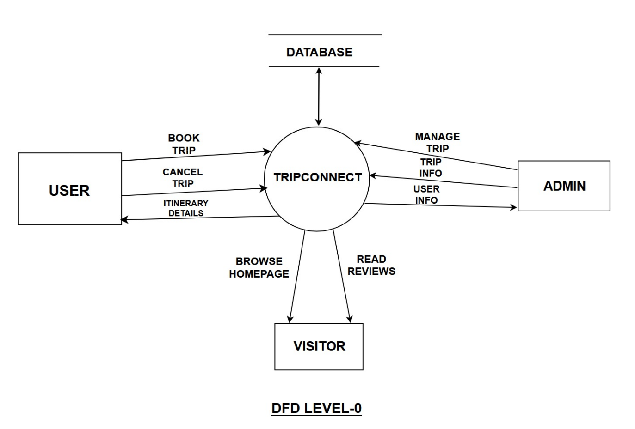
- Dataflow Diagram

4. Activity Diagram

- Guest Visitor

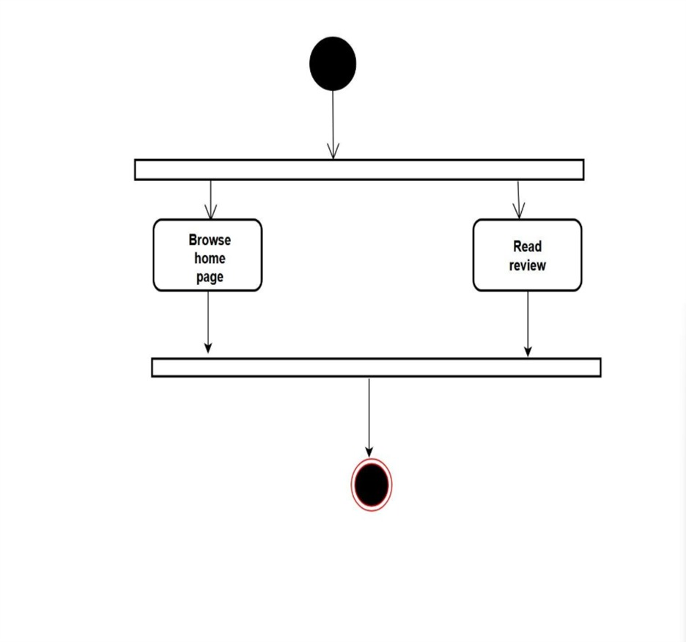

- User

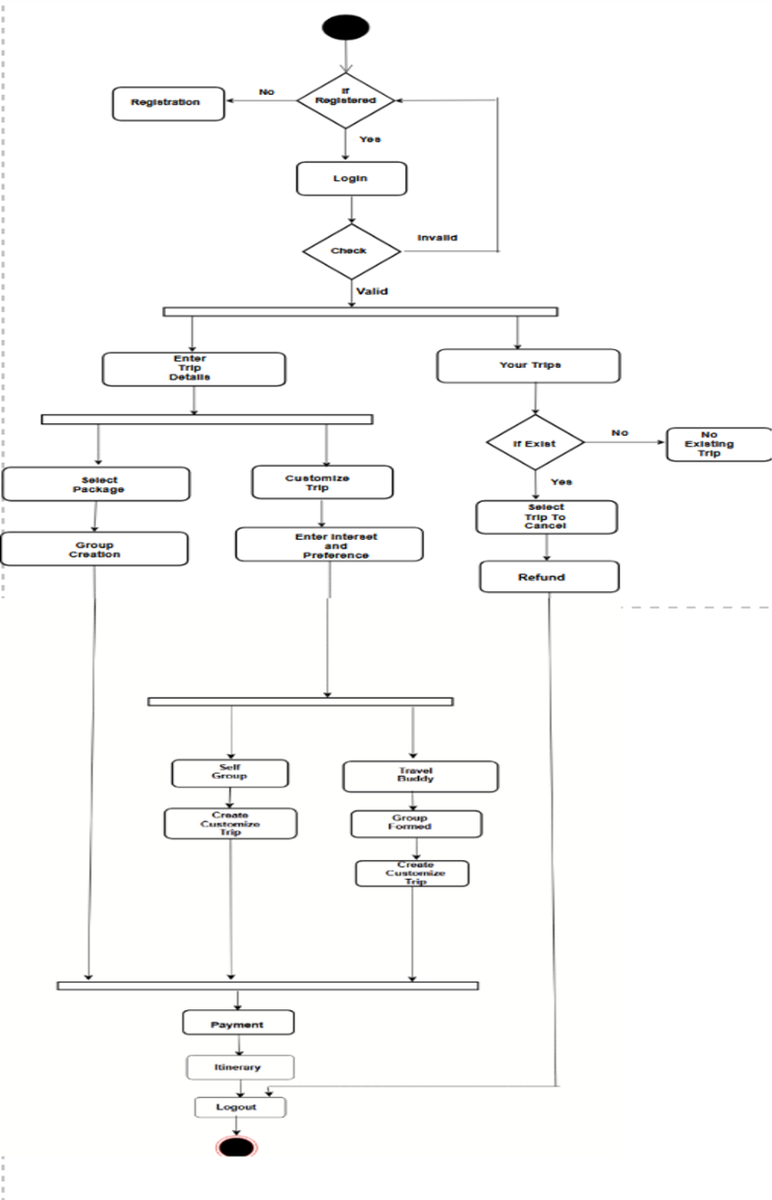

- Admin

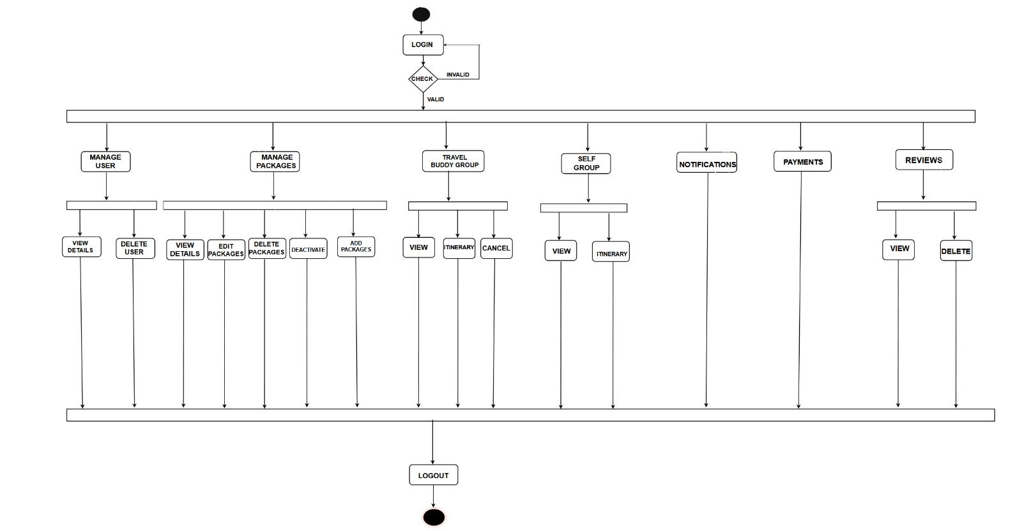
5. Sequence Diagram
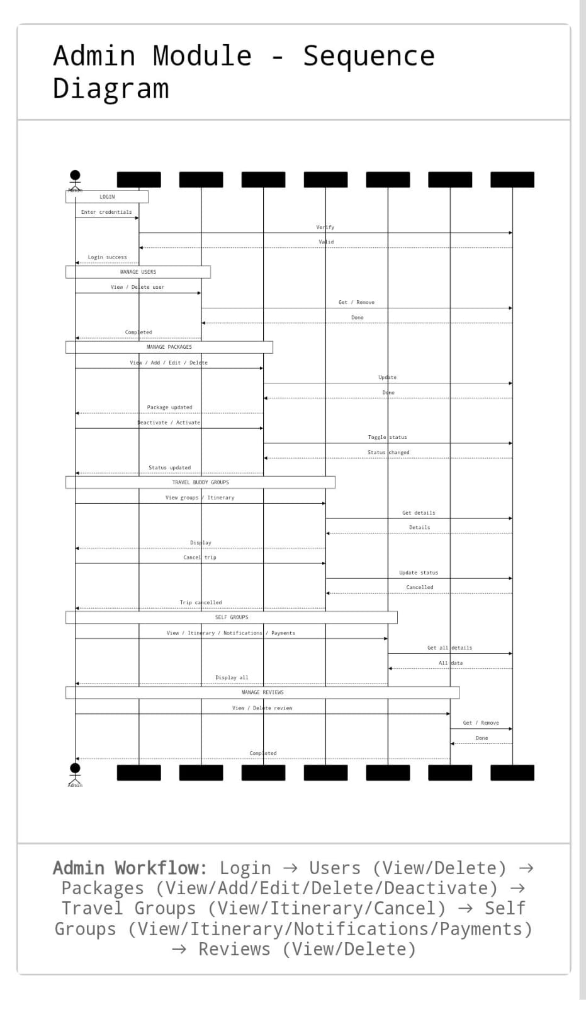

Coding

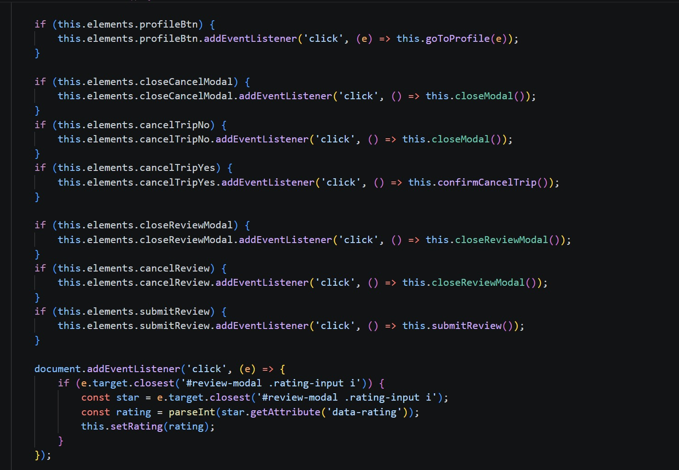
Review System

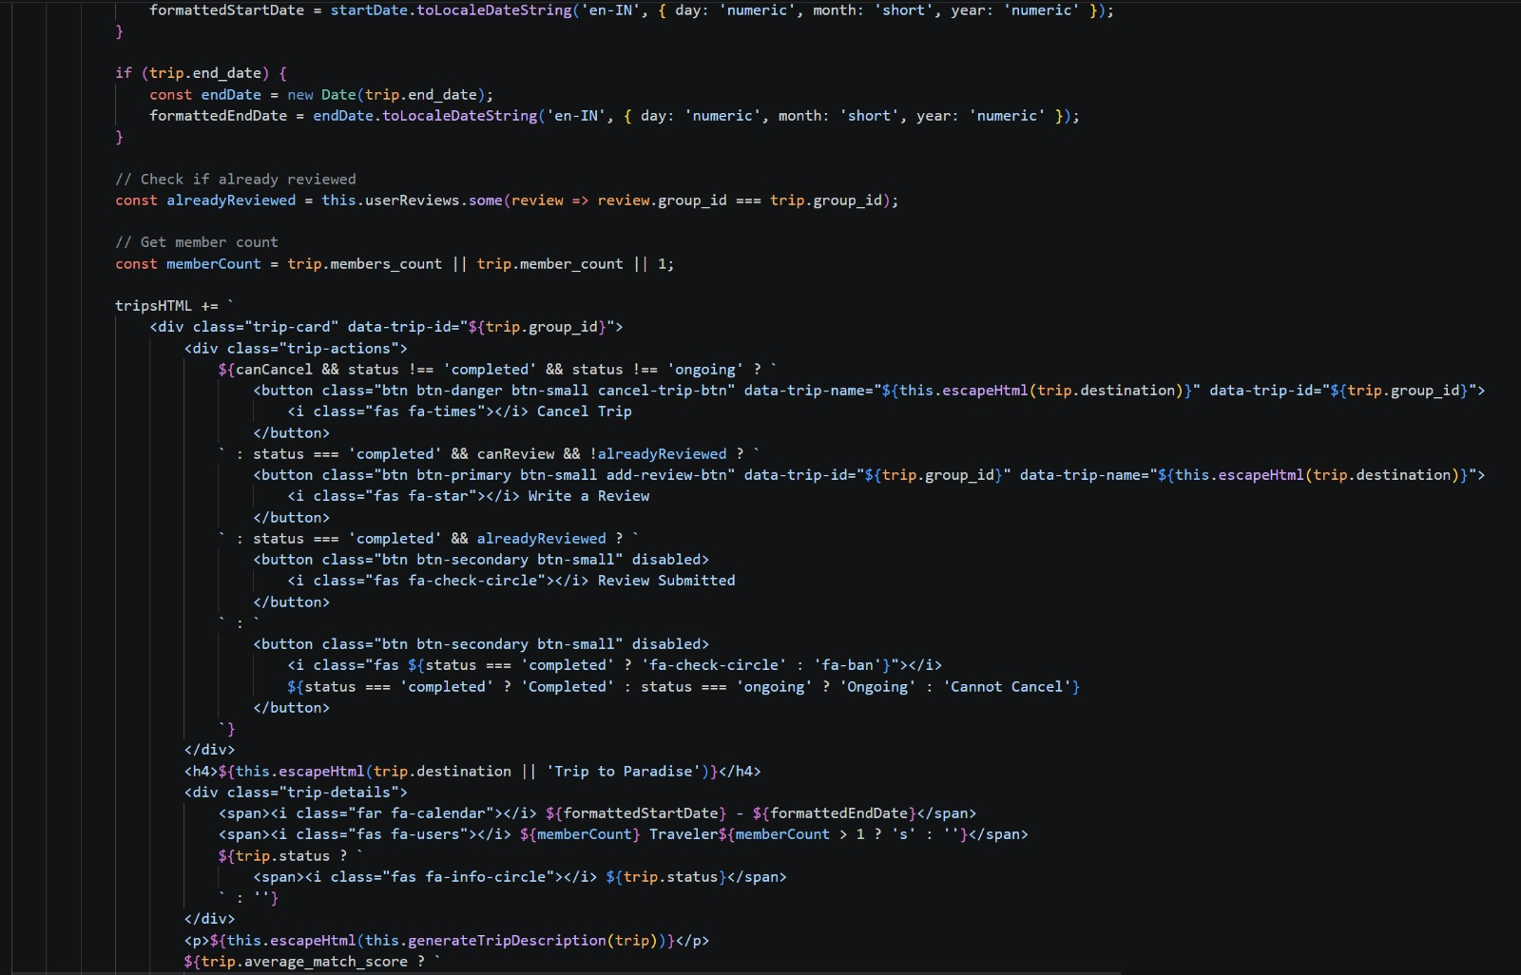
Trip Cancellation
Login
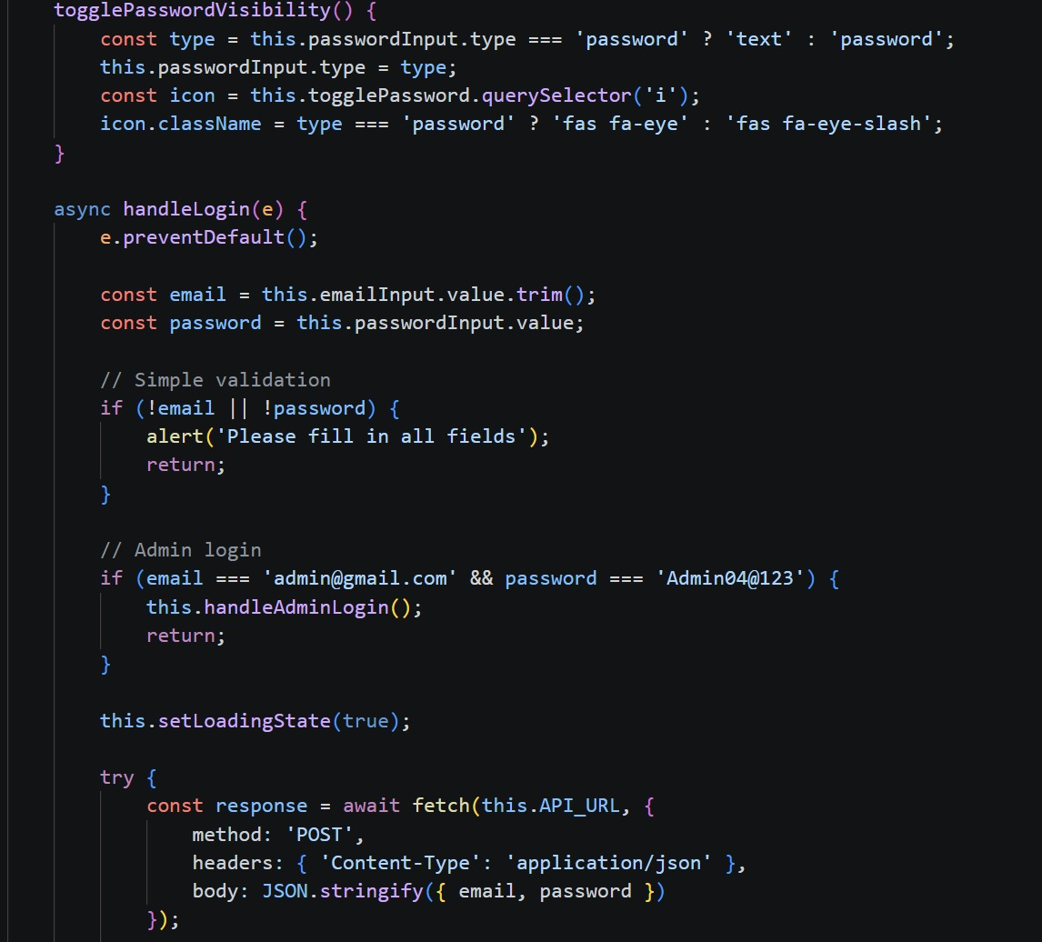

Sign Up (user id formation)

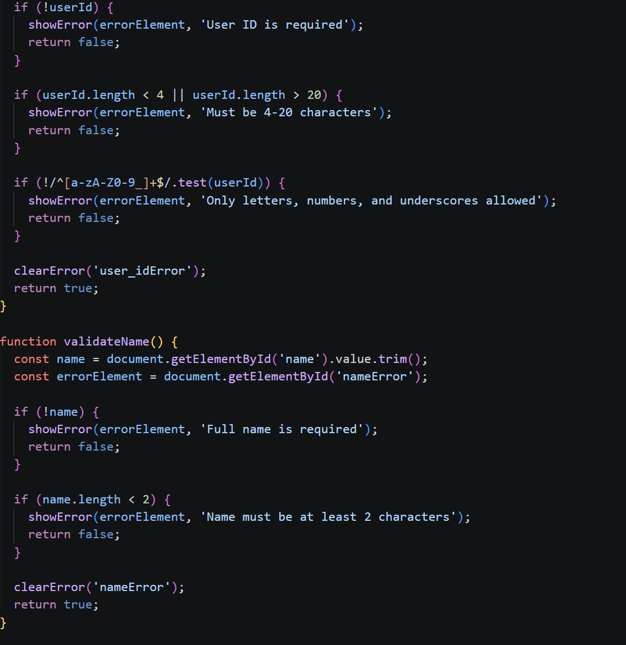

Sign Up (password strength requirement)

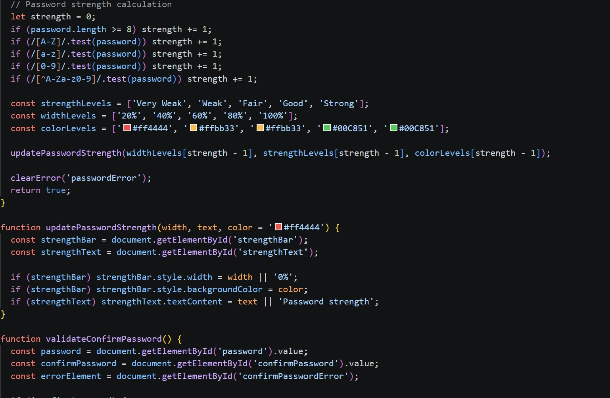

Travel Preferences
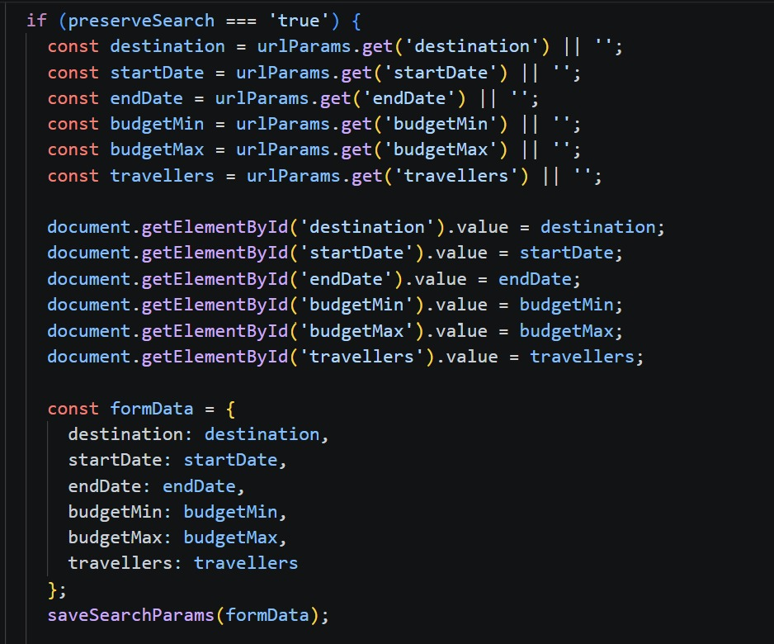

Fetch Packages
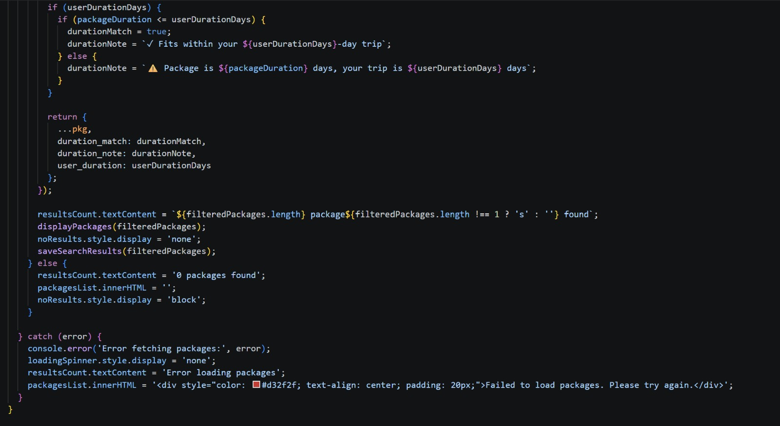

Interest Selection
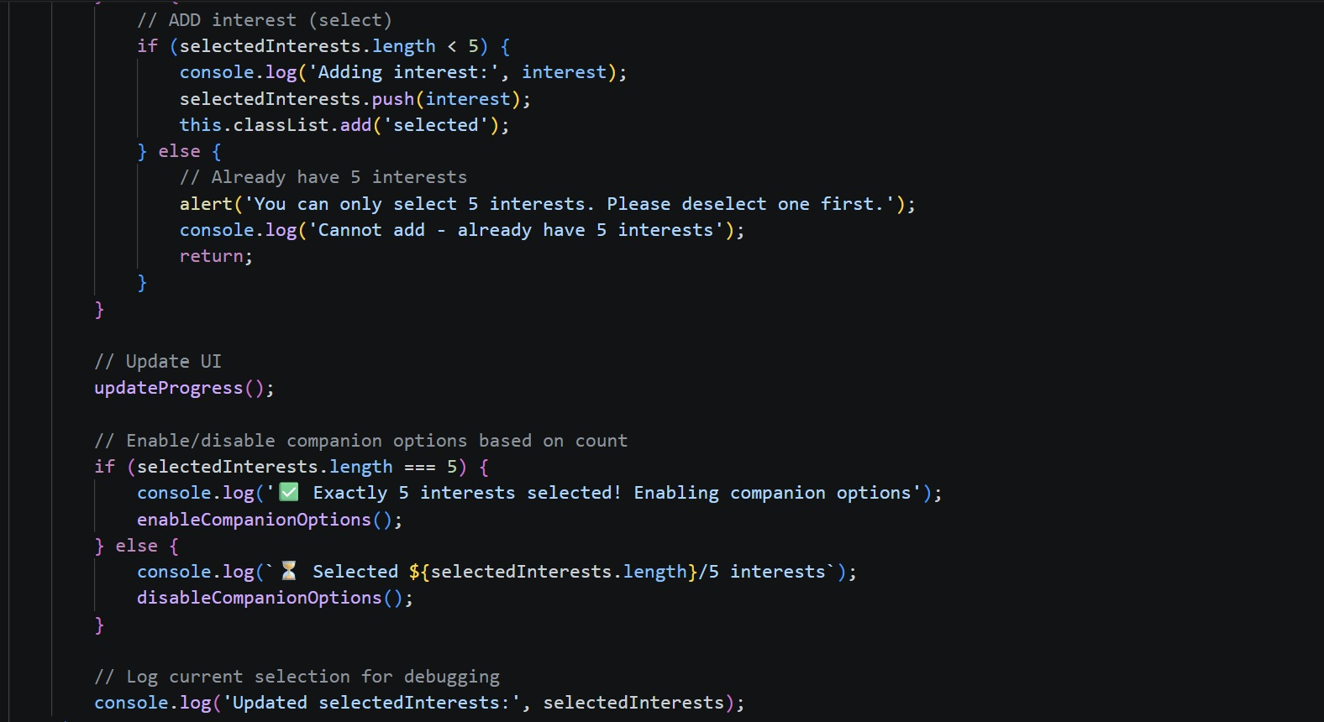

Companion Selection
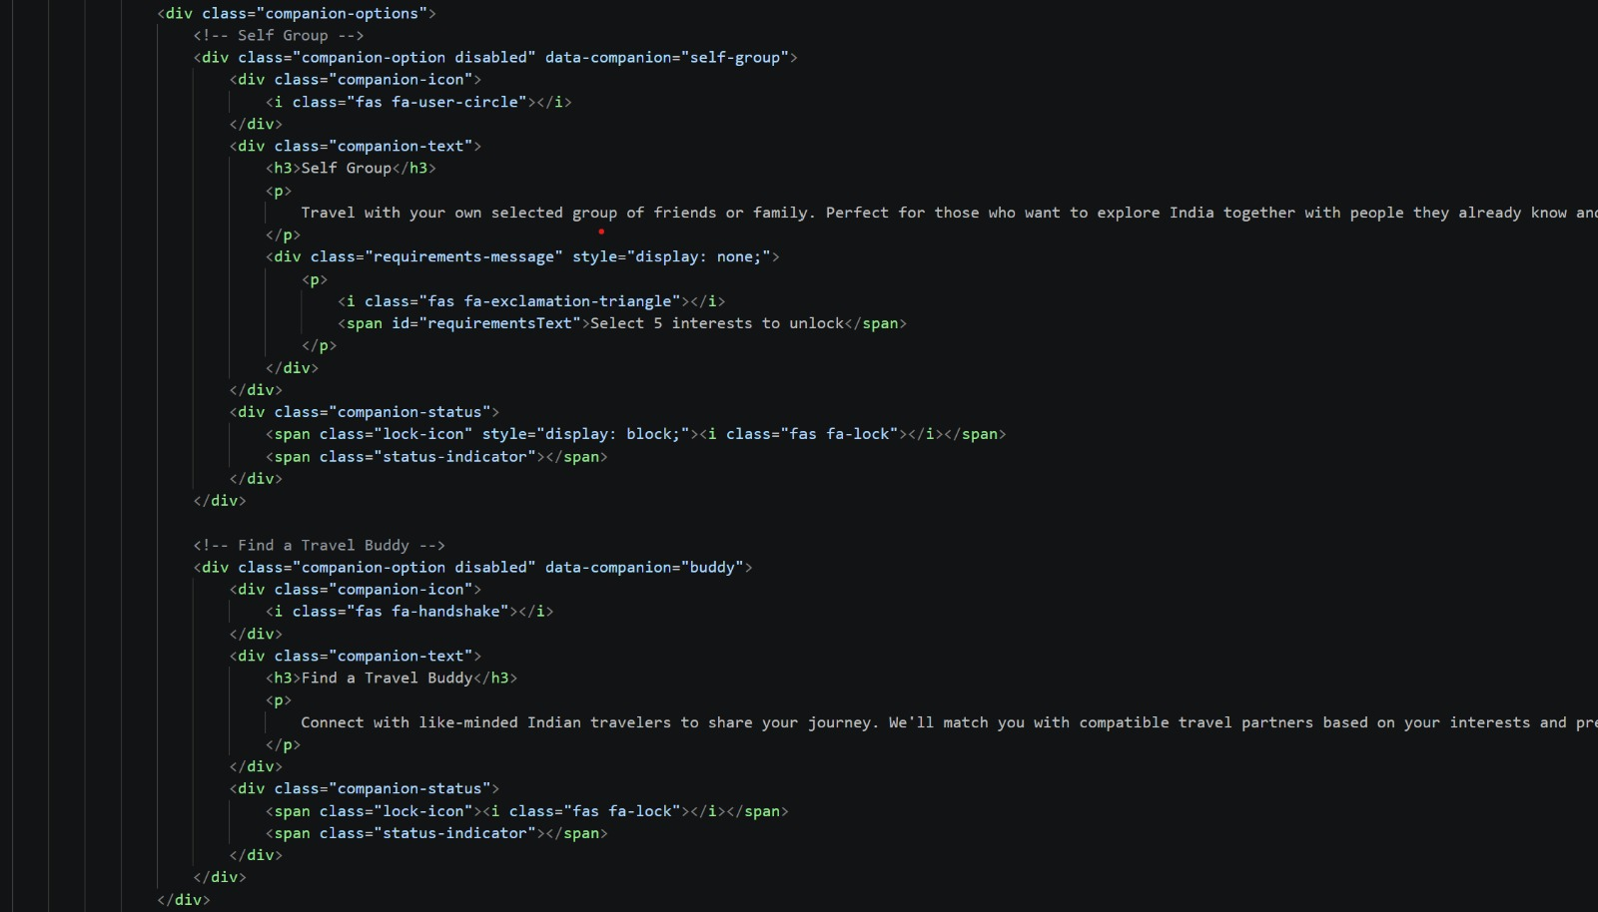

Member Details
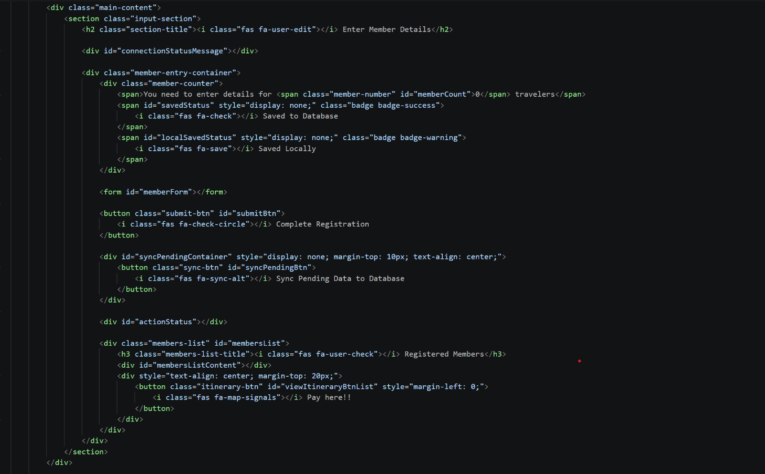

Calculate match score

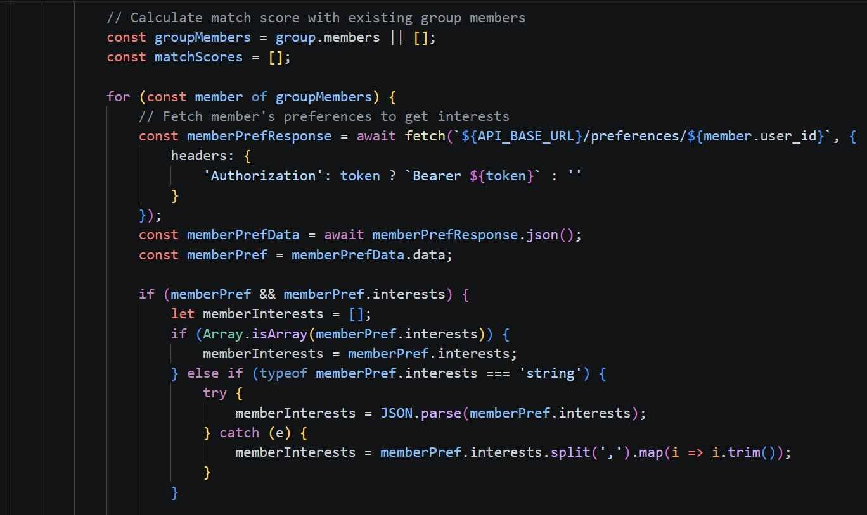

Calculate Interest Match

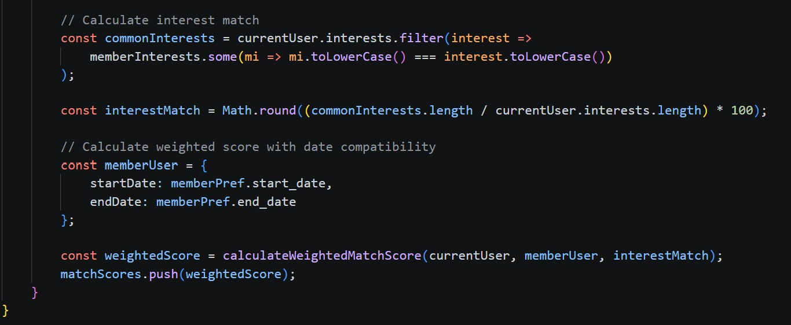

Calculate match Score
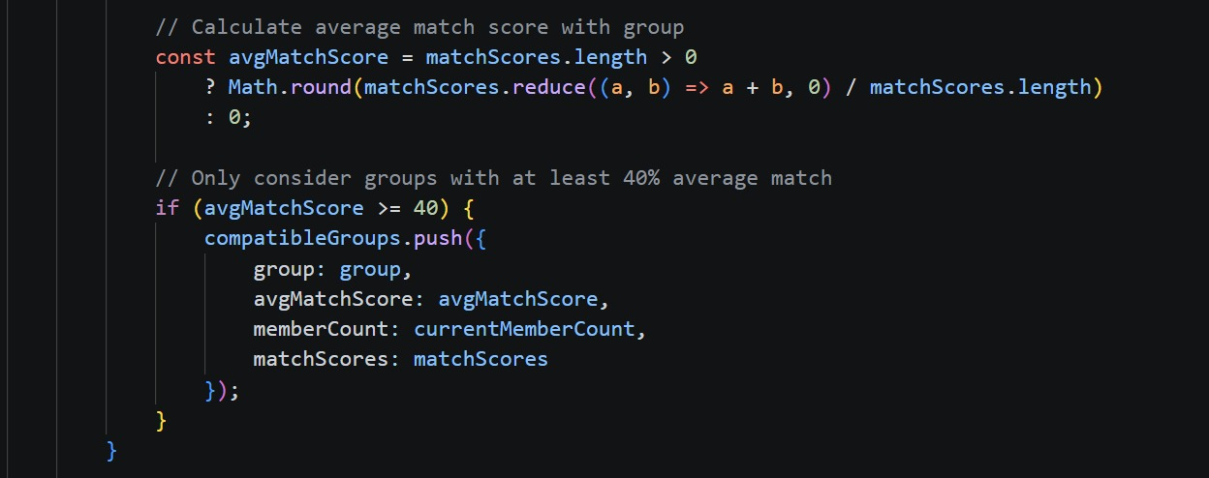

Percentage Compatibility
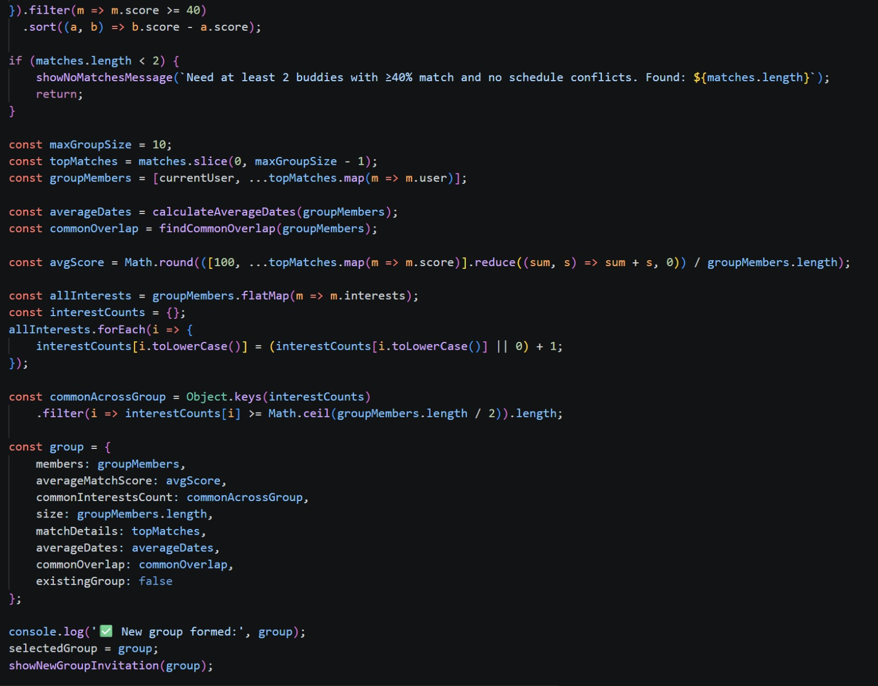

Admin (User Management)
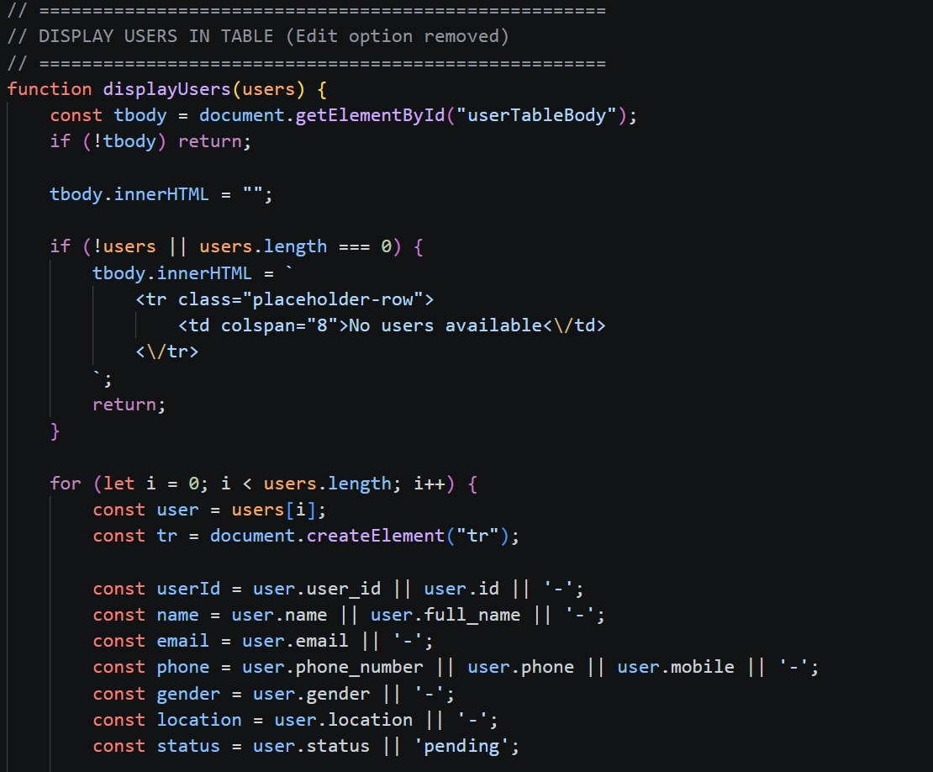

Package Management
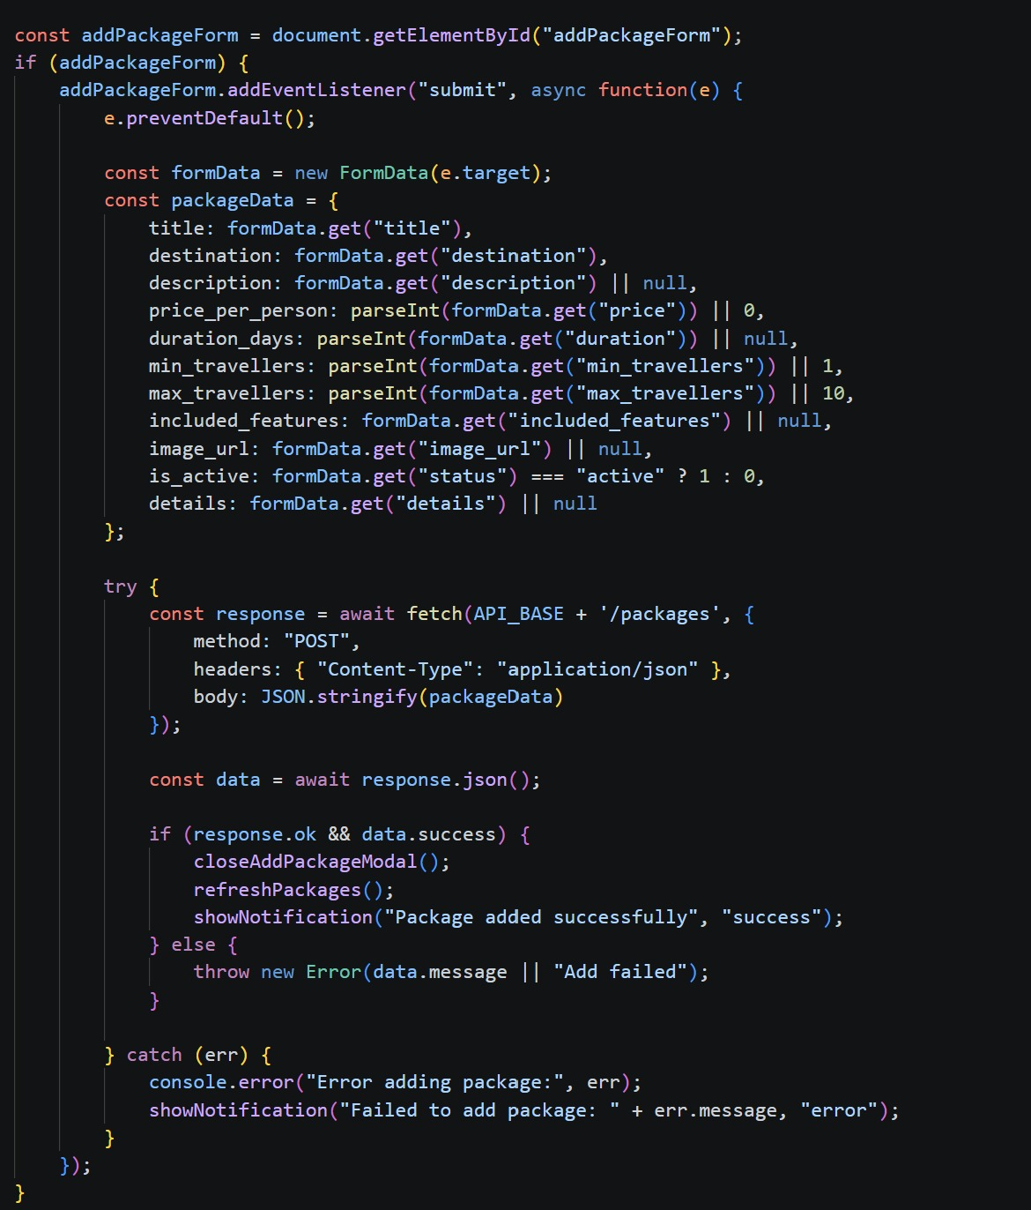

Testing
Software testing ensures that the TripConnect meets the specified requirements, functions as expected, and can be implemented with consistent characteristics. Testing is a crucial phase in the development process to verify that the system performs the intended tasks efficiently and effectively. Testing is the process of making sure that the program performs the intended tasks.
1. Unit Testing: Each component or part of the system is tested individually.
2. Module Testing: A collection of dependent components such as an object class, procedures and functions are tested in the testing.
3. Integrating Testing: In this, many units tested modules are combined into sub systems, which are then tested.
4. System Testing: Entire system software is tested. It is a testing of the system against its initial objectives.
• Test Cases
• Unit Tests
- Conducted by developers in a controlled test environment. o Focus on individual components like user authentication, form validation, and database transactions.
- Helps identify and resolve issues early in development. • System Tests o Ensures that the system functions as expected when all modules are integrated.
- Simulates real-world usage scenarios, including multiple users accessing different system functionalities simultaneously. o If the deployment environment differs from the development environment, testing should be conducted on a similar platform for accuracy.
• User Interface Testing
- The TripConnect should provide a smooth user experience. UI testing ensures that: o Web pages display correct content without spelling or grammatical errors.
- Fonts and design elements are consistent across all pages. o Error messages are clear, correctly formatted, and relevant to the associated fields.
- Sufficient spacing is maintained between field labels, columns, rows, and messages. o Buttons follow a standardized format and size.
- No broken links or images are present. o Confirmation messages appear for update and delete operations. o Forms allow users to enter and submit all required information. o Fields accept only valid data (e.g., numeric fields should not accept letters).
- Negative values are handled correctly in numeric fields. o The maximum character limit for text fields prevents data truncation.
- Dropdown lists and selection boxes display options in chronological or logical order.
• Functional Testing
- Mandatory fields should be validated against system dates. o The system should not display error messages for optional fields.
- All functions, such as user authentication, event registration, attendance tracking, and faculty-student interaction, should work as expected.
- Error handling should redirect users to custom error pages when necessary.

User Interface


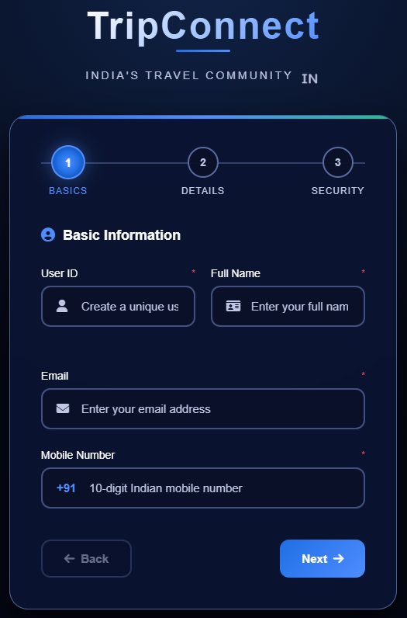

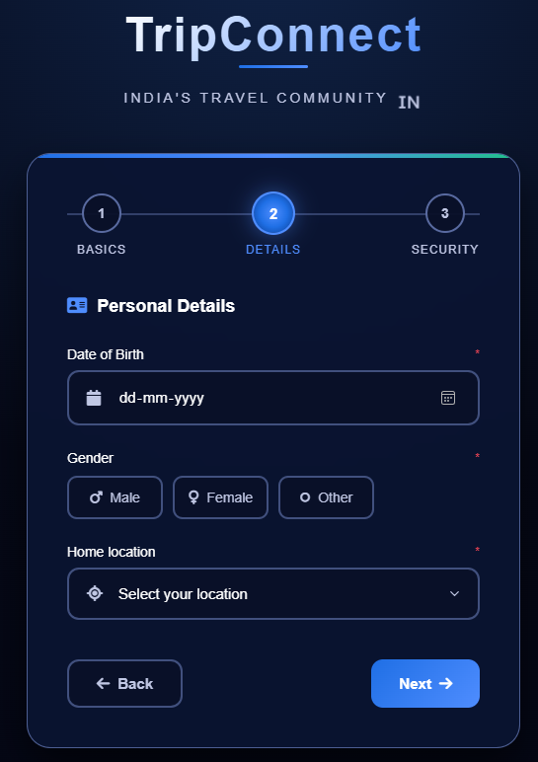

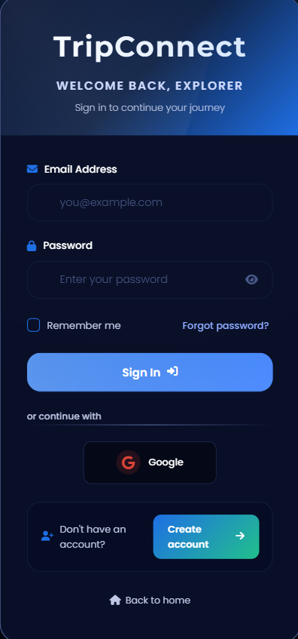

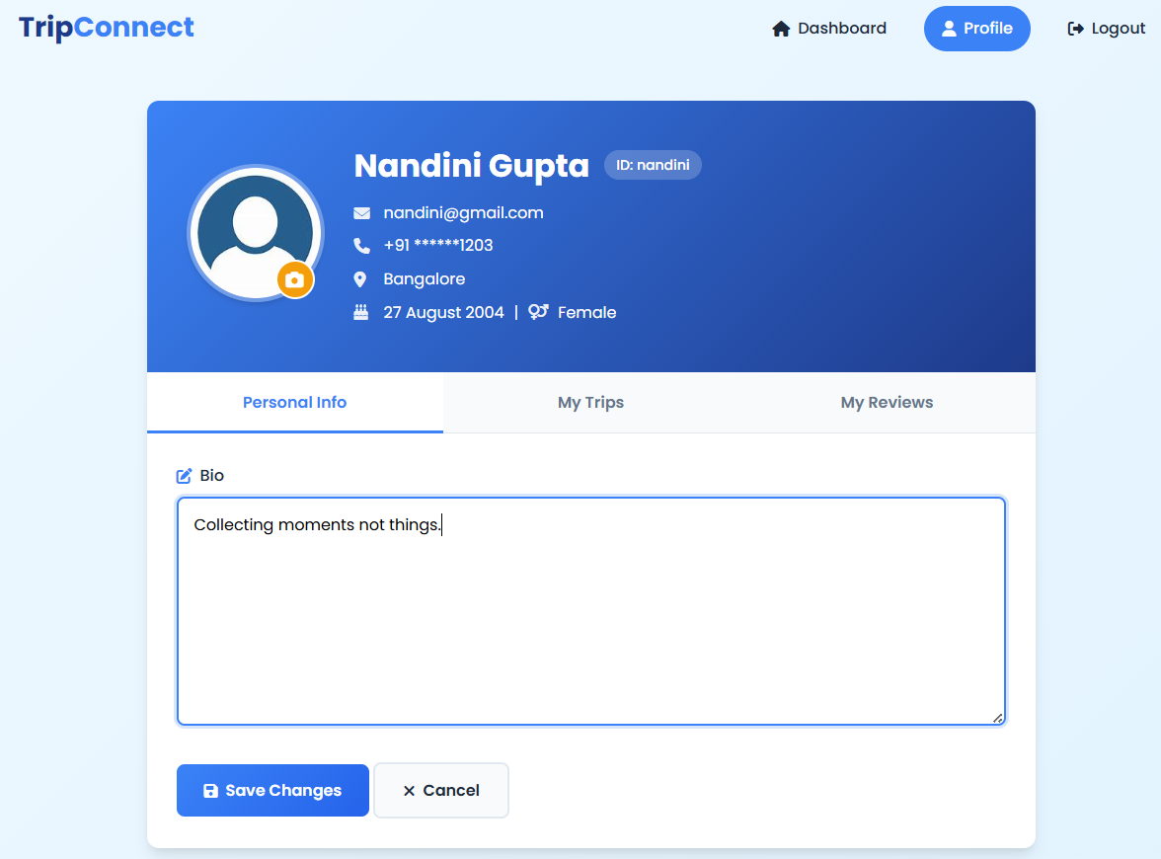
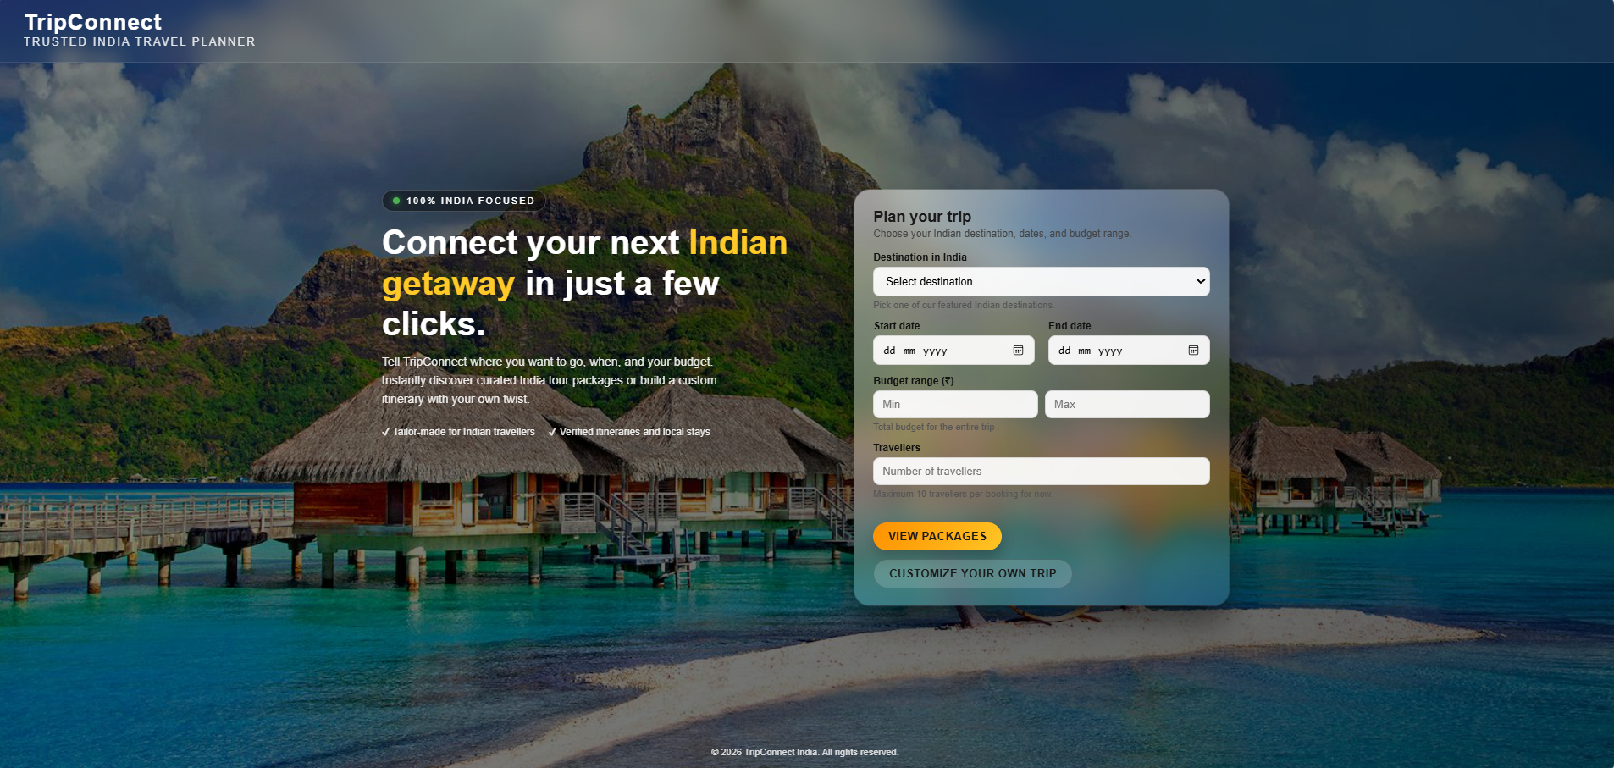
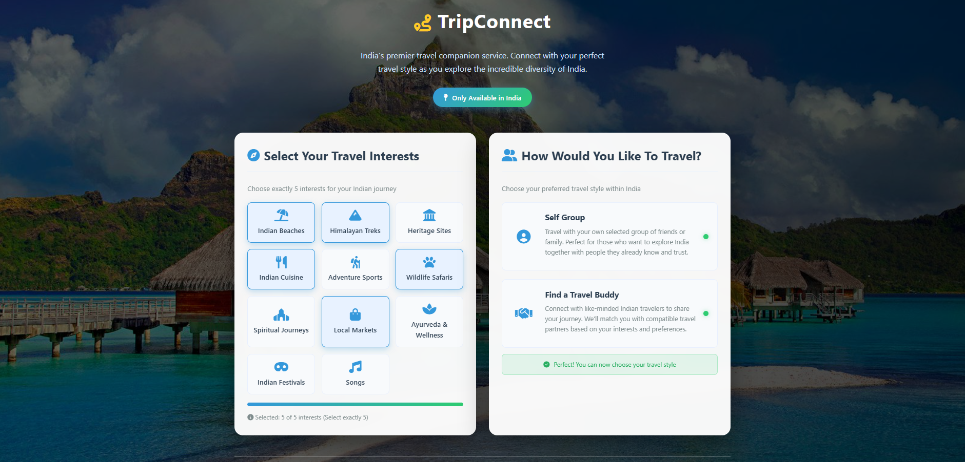
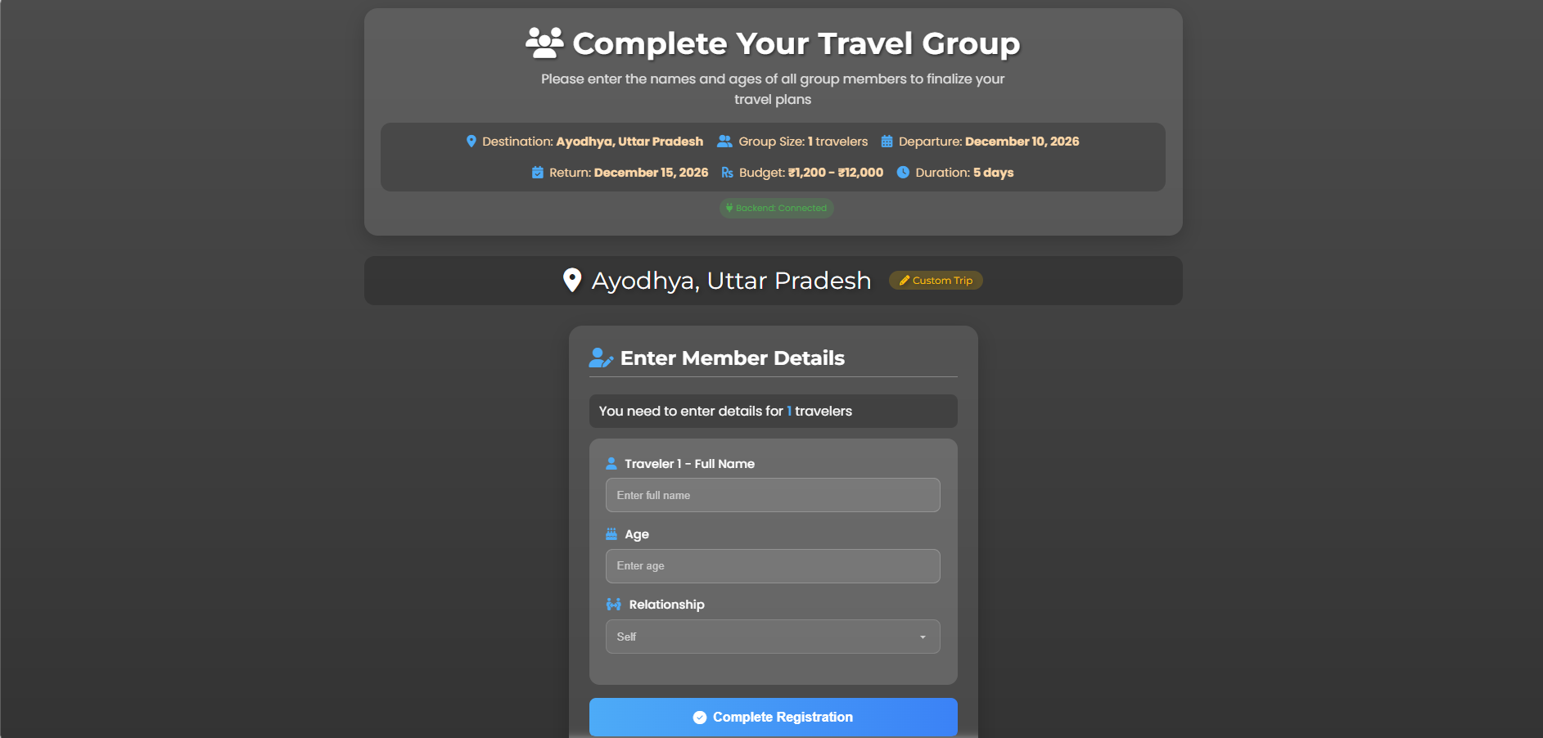

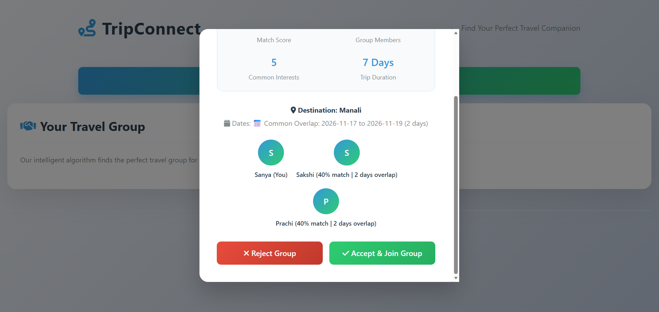

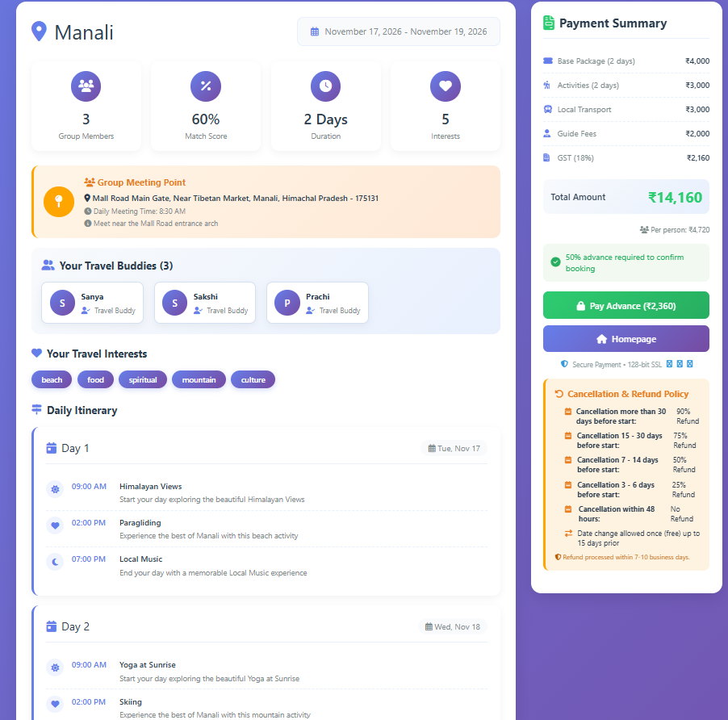

Appendices

Definitions:
● API (Application Programming Interface): A set of protocols and tools that allow different software components to communicate with each other.
● Encryption: The process of encoding data to protect it from unauthorized access.
● User: An individual who interacts with the system, including both administrators responsible for managing the application and end-users marking their attendance.
● SRS (Software Requirements Specification): The document that outlines the functional and non-functional requirements of the software product being developed.
● Database: A structured collection of data that stores information related to users, their facial features, and attendance records.

References
- IEEE Std 830-1998 – IEEE Recommended Practice for Software Requirements Specifications.
- Sommerville, Ian. Software Engineering, 10th Edition, Pearson, 2016.
- Pressman, Roger S. Software Engineering: A Practitioner’s Approach, 8th Edition, McGraw-Hill, 2014.
- TutorialsPoint. “Software Requirements Specification (SRS) Tutorial.” Available at: https://www.tutorialspoint.com/software_engineering/software_requirements.htm
- GeeksforGeeks. “Software Requirements Specification (SRS) – Introduction.” Available at: https://www.geeksforgeeks.org/software-requirements-specification-srs/

